Berlin, 27.09.2021

Stefan Spitzer

Stefan.spitzer@bam.de

**Goal**

This standard procedure is a first approach to obtain comparable data of hybrid mixtures. So far in literature about hybrid mixtures only phenomena were observed, and no experiments were repeated or values were stated as comparable and dependable. In addition, none of the papers measured the amount of gas after mixing or stated the accuracy or the scattering of the gas fraction. The goal of this procedure is to narrow all technical parameters to a reasonable range, within which all test facilities will obtain comparable results.

**Modifications:**

* Additional pressure sensor. 1 bar pressure sensor that can be shutoff with a valve would be the optimum (PIR 4 in the schematic), otherwise a 10 bar pressure sensor (PIR3 in the schematic) without valve
* Gas analyzer

First of all, another piezo-resistive pressure sensor must be added to the 20L-sphere, to measure all the pressures before and after injection (see Figure 1, PIR 3 or 4). The two piezo-electric pressure sensors can’t measure static pressures so for hybrid mixtures they are not sufficient (see Figure 1, PIR 1 & PIR 2). The piezo-resistive pressure sensor should have a range between 0-1 bar and a resolution of at least 0,1 mbar. This one must be separated while conducting the explosion tests with an extra valve.

We added two pressure sensors, one with the stated features and another one with a range between 0-10 bars and a resolution of 1 mbar (PIR 3).

For measuring the amount of gas an analyzing system must be connected to the 20L-sphere, as well separated by a valve.

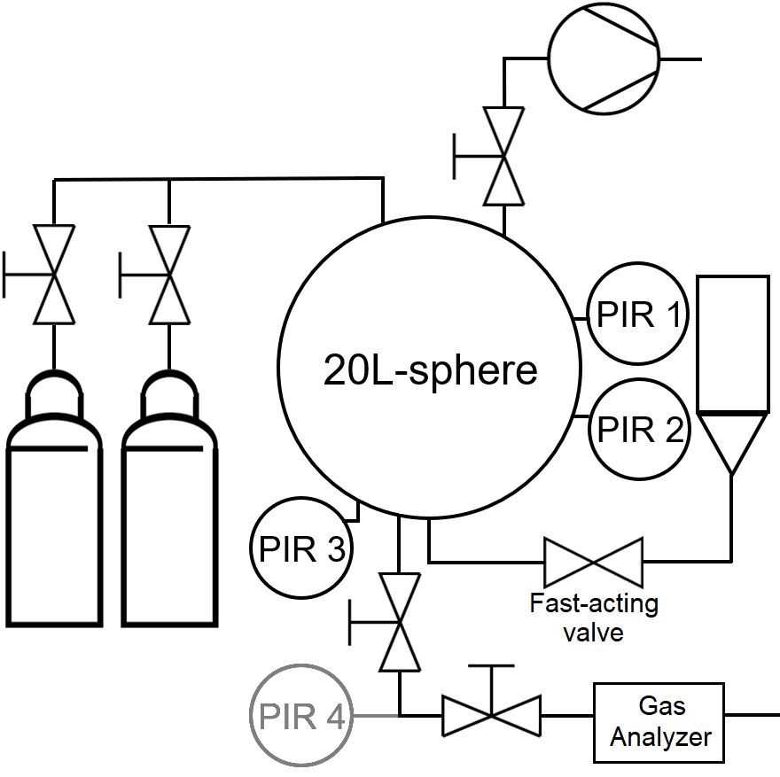

Figure 1: 20L-sphere with modifications for testing hybrid mixtures

1. **Pre-Test 1 – Leakage rate**

It takes about 3-5 minutes to fill in all the partial pressure fractions of the different gases. So, the accuracy and the precision of the amount of gases is dependent on the leakage-rate of the 20L-sphere. The leakage rate should be lower than 1mbar/minute.

* Evacuate the 20L-sphere to 100 mbar.
* Close all valves (except for the one leading to PIR 4)
* Note the pressure according to PIR 3 and/or PIR 4 and note the time
* After the given times note pressure according to PIR 3 and/or PIR 4

|  |  |  |  |  |
| --- | --- | --- | --- | --- |
| **Time spent** | **PIR 3 and or 4** | **Time** | **PIR 3 and or 4** | **Time** |
| [seconds] | [mbar] | hh:mm:ss | [mbar] | hh:mm:ss |
| 0 |  | : : |  | : : |
| 60 |  | : : |  | : : |
| 120 |  | : : |  | : : |
| 180 |  | : : |  | : : |
| 300 |  | : : |  | : : |
| 600 |  | : : |  | : : |

1. **Pre-Test 2 – Gas amount – deviation and scattering**

These tests are conducted without ignition source or dust.

The amount of gas is calculated after the following equation:

Cgas=Pgas/(PV+PIPR-PIPD) (1)

Cgas = Concentration of gas [Mol-%]

Pgas = Partial pressure fraction of gas

PV = partial vacuum; 400 mbar ± 2 mbar

PIPR = pre-ignition pressure rise (Pd in Ksep); 0,64 bar ± 0,01 bar

PIPD = Post-injection pressure drop

There is a pressure-drop after injecting the air due to the increased temperature because of the fast compression (Post-injection pressure drop, PIPD, see Figure 2). This should always be recorded in these tests for at least three minutes. Normally the ignition takes place at the peak pressure. Due to the explosion this pressure drop after equilibration cannot be recorded so for the explosion tests the obtained values are averaged.

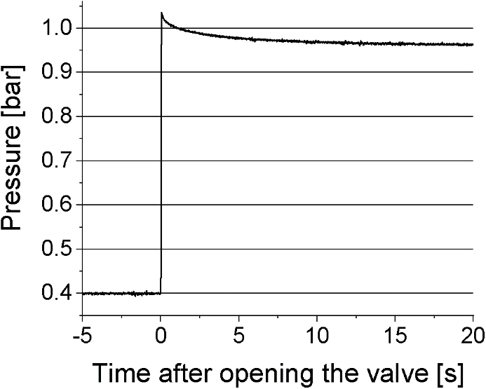

Figure 2: Recorded pressure against time after opening the fast-acting valve without igniter and without dust

|  |  |  |  |  |  |  |  |  |  |
| --- | --- | --- | --- | --- | --- | --- | --- | --- | --- |
| Test | Air (target) | Air  (real value) | burnable gas  (target) | burnable gas  (real value) | PIPR (target) | PIPR  (real value) | PIPD after 180 seconds | Cgas (calc.) | Cgas (measured) |
|  | [mbar] | [mbar] | [mbar] | [mbar] | [mbar] | [mbar] | [mbar] | Mol-% | Mol-% |
| 3 % | 370 |  | 400 | , | 640 |  |  |  |  |
| 3 % | 370 |  | 400 | , | 640 |  |  |  |  |
| 3 % | 370 |  | 400 | , | 640 |  |  |  |  |
| 3 % |  |  |  | , |  |  |  |  |  |
| 3 % |  |  |  | , |  |  |  |  |  |
| 3 % |  |  |  | , |  |  |  |  |  |
| 9 % | 310 |  | 400 | , | 640 |  |  |  |  |
| 9 % | 310 |  | 400 | , | 640 |  |  |  |  |
| 9 % | 310 |  | 400 | , | 640 |  |  |  |  |
| 9 % |  |  |  | , |  |  |  |  |  |
| 9 % |  |  |  | , |  |  |  |  |  |
| 9 % |  |  |  | , |  |  |  |  |  |

**Note:** the green fields only have to be filled, if the deviation is above 0,2 Mol-%.

The measured and the calculated values might be different, in this case the following equation should be used

Cgas=Pgas/(PV+PIPR-PIPD)-Deviationconc. (2)

with the concentration dependent deviation subtracted at the end.

|  |  |  |  |  |  |
| --- | --- | --- | --- | --- | --- |
|  | Cgas (calculated) | Cgas (measured) | Differencecalc.-measued | Differencemeanvalue.-measured | PIPD |
|  | Mol-% | Mol-% | Mol-% | Mol-% | [bar] |
| Test 1 |  |  |  |  |  |
| Test 2 |  |  |  |  |  |
| Test 3 |  |  |  |  |  |
|  | Mean value | Mean value | Mean value | Max. value |  |
|  |  |  |  |  |  |
| Test 4 |  |  |  |  |  |
| Test 5 |  |  |  |  |  |
| Test 6 |  |  |  |  |  |
|  | Mean value | Mean value | Mean value | Max. value |  |
|  |  |  |  |  |  |
| Test 7 |  |  |  |  |  |
| Test 8 |  |  |  |  |  |
| Test 9 |  |  |  |  |  |
|  | Mean value | Mean value | Mean value | Max. value |  |
|  |  |  |  |  |  |
| Test 10 |  |  |  |  |  |
| Test 11 |  |  |  |  |  |
| Test 12 |  |  |  |  |  |
|  | Mean value | Mean value | Mean value | Max. value | Overall Average |
|  |  |  |  |  |  |

The values in light green are the concentration-dependent deviation, the maximum of the three values in light blue is the highest possible scattering.

This step shall be repeated, and the amount of gas adjusted to a higher or lower level (according to the deviation), so that the desired amount of gas (here 3 and 9 %) is measured in the end. In table 1 the green spaces are for these tests with the adjusted partial pressures.

**Note:** For safety reasons we took CO2 instead of methane for this pre-test. Considering the low pressures and being far away from boiling temperatures ideal gas behavior was assumed for all the mixture components

**Take the mean value deviation (light green) and the overall average of the PIPD (light red) for the calculation of the gas concentration in the tests**

1. **Explosion Tests – measuring hybrid safety characteristics**

Parameters:

* Moisture content between 5 and 10 %.

If this can not be measured this should be stated in the data

* Methane purity > 99%
* Ignition type: chemical igniter
* Ignition energy: 2 x 1000 J
* Ignition delay time: 60 ms
* Partial vacuum before injection (PV): 400 mbar ± 2 mbar
* Pre-ignition pressure rise (PIPR or Pd): 0,64 bar ± 0,01 bar

Calculation of concentration:

Cgas=Pgas/(PV+PIPR-PIPDmean)-Deviationconc.

The tests, that should be conducted are in the following table.

|  |  |  |  |
| --- | --- | --- | --- |
| **Corn Starch** | **Methane Concentration** | | |
| **g/m³** | **Mol-%** | | |
|  | **0** | **3** | **9** |
| 0 | 0 |  |  |
| 60 | 0 |  |  |
| 125 | 0 |  |  |
| 250 | 0 |  |  |
| 500 | 0 |  |  |
| 750 | 0 |  |  |
| 1000 | 0 |  |  |

Each test shall be conducted once. At the maximum pressure and maximum rate of pressure rise for each Methane concentration the tests shall be repeated twice to an overall number of 3 tests. The last test for 0 % and 3 % of methane, that did not show an ignition phenomenon (pex < 0,5 bar) shall be repeated as well twice to an overall number of 3 tests.

**Note 1:** The pressure in the dust container must be adjusted for higher amounts of dust. The PIPR should always be around 0,64 bar ± 0,01 bar so that the calculated amount of gas is right.

**Note 2:** All the data, the excel-File and all the pressure time-curves shall be handed over for a better comparison.